Python Activity-Based Learning

1.
Attendance Recovery Computation: Calculate current attendance percentages and determine the minimum consecutive classes required to reach an eligibility threshold under different future attendance scenarios.
Sol:

Problem statement
Calculate a student's current attendance percentage and determine the minimum number of consecutive classes the student must attend to reach a required attendance percentage.

Objectives
- Calculate attendance percentage.
- Use a loop to find the minimum future classes needed.
- Display a clear eligibility result.

Assumptions
- Classes held and classes attended are non-negative integers.
- Classes attended cannot exceed classes held.
- The required percentage is between 0 and 100.

Algorithm
- Read classes held, classes attended, and required percentage.
- Validate the inputs.
- Calculate current attendance percentage.
- If the target is already reached, print 0 additional classes.
- Otherwise, repeatedly add one attended class and one held class until the target is reached.
- Print the percentage and additional classes needed.

Pseudocode
- START
- Read Input held, attended, target
- if held < 0 OR attended < 0 OR attended > held OR target < 0 OR target > 100:
print Invalid input
- else:
if held == 0:
current = 0
else:
current = attended / held * 100
- Set extra = 0
- Now, while (attended + extra) / (held + extra) * 100 < target:
extra+=1
- print percentage, extra
- STOP

Flowchart

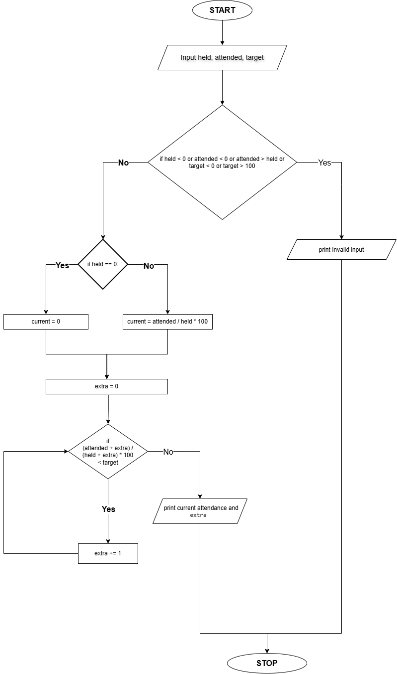

Source Code
held = int(input("Enter total classes held: "))
attended = int(input("Enter classes attended: "))
target = float(input("Enter required attendance percentage: "))
if held < 0 or attended < 0 or attended > held or target < 0 or target > 100:
print("Invalid input.")
else:
if held == 0:
current = 0
else:
current = attended / held * 100
extra = 0
while (attended + extra) / (held + extra) * 100 < target:
extra += 1
print(f"Current attendance: {current:.2f}%")
print("Additional classes to attend:", extra)

Test Cases

- Input: 40; 32; 75
  - Expected result: Current attendance: 80.0 %; Additional classes to attend: 0
- Input: 20; 12; 75
  - Expected result: Current attendance: 60.0 %; Additional classes to attend: 12 •
- Input: 10; 10; 75
  - Expected result: Current attendance: 100.0 %; Additional classes to attend: 0

Output

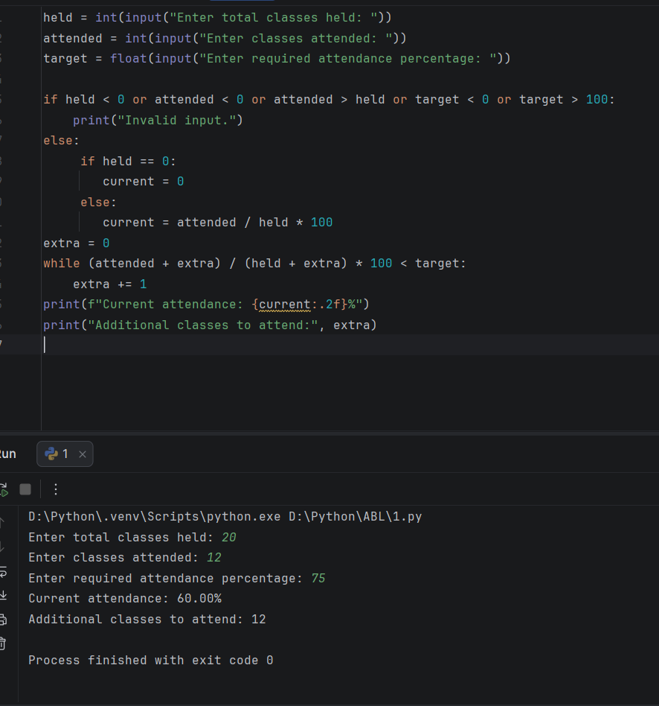
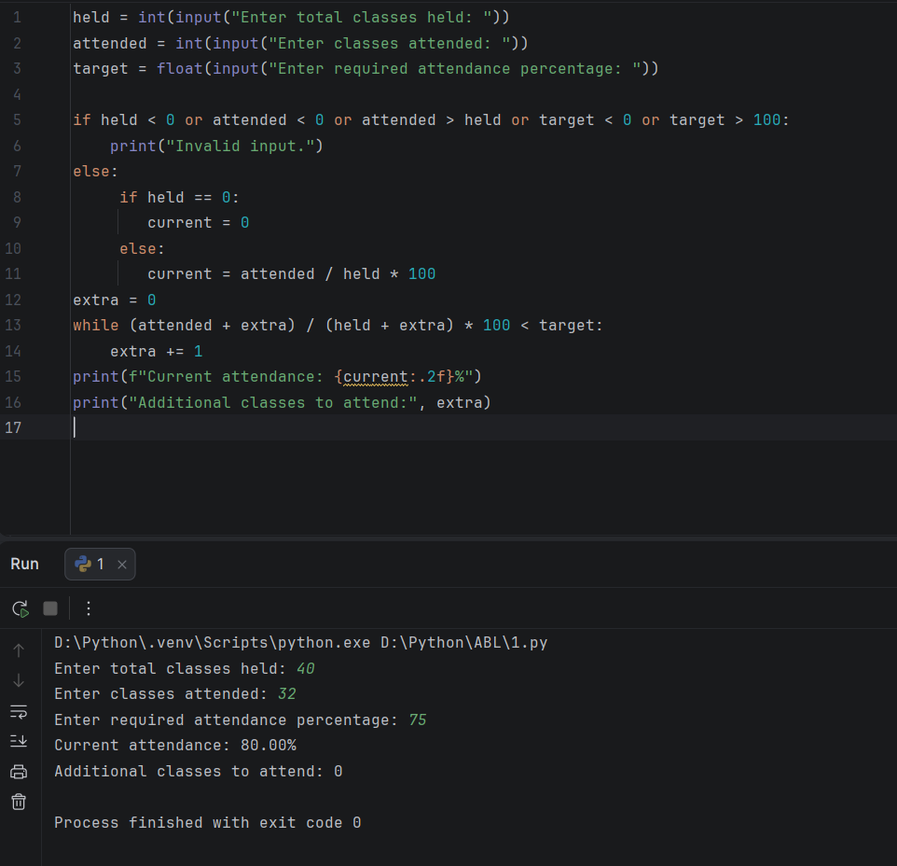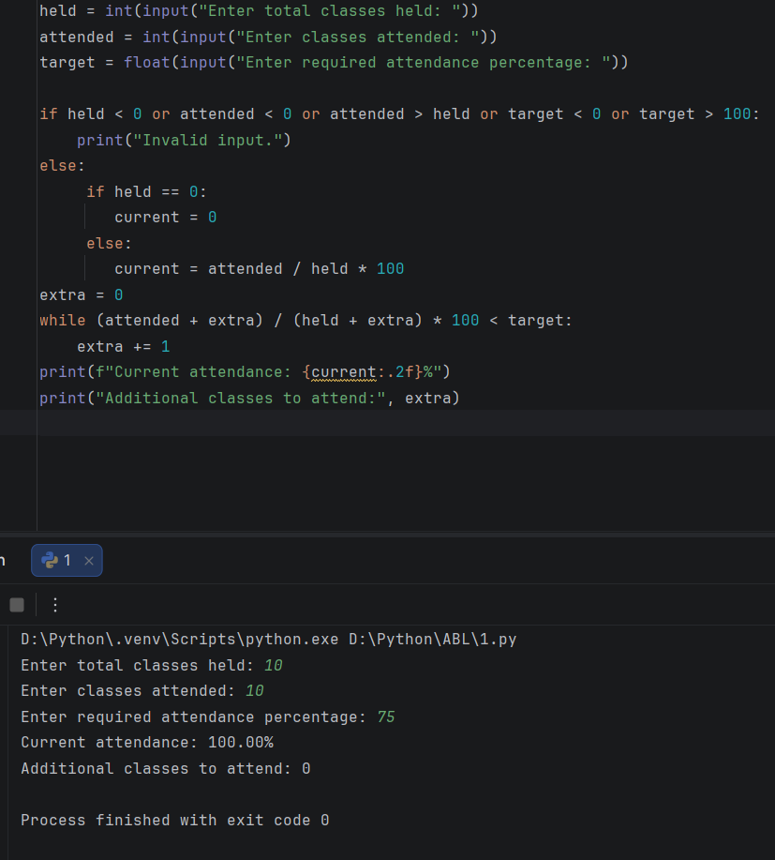

Conclusion
The program calculates attendance and uses repetition to find the minimum number of future classes required to reach the target

2.
Food Waste Monitoring System: Compare prepared meals, meals served, and leftovers across several days; calculate wastage percentages and identify days exceeding acceptable limits.
Sol:

Problem statement
Compare the number of meals prepared, meals served, and leftovers over several days; calculate waste percentages and identify days that exceed an acceptable limit.

Objectives
- Calculate leftover meals.
- Calculate waste percentage for each day.
- Identify days above the supplied waste limit.

Assumptions
- Prepared and served meals are non-negative integers.
- Meals served cannot exceed meals prepared.
- Waste percentage is leftovers divided by meals prepared, multiplied by 100.

Algorithm
- Read the number of days and acceptable waste percentage.
- For each day, read meals prepared and served.
- Validate the values. 4
- Calculate leftovers and waste percentage.
- Classify the day as within limit or excessive waste.
- Display each day's result.

Flowchart

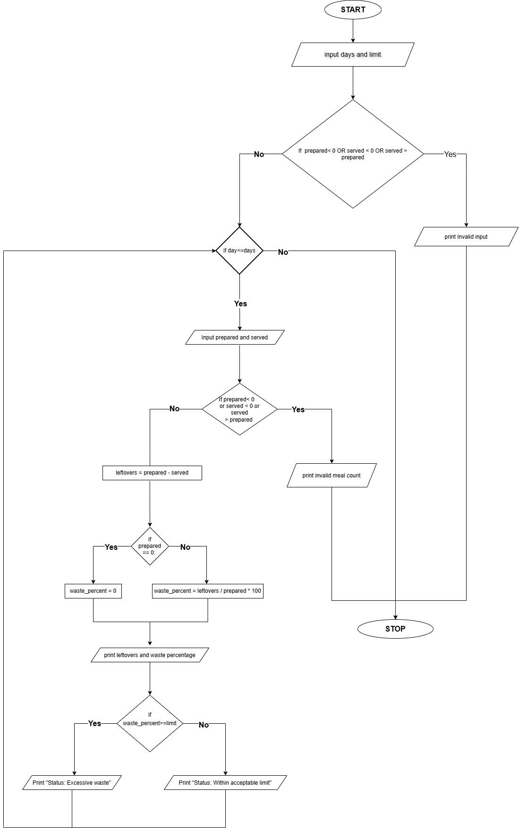

Pseudocode
START
INPUT days, limit
IF days <= 0 OR limit < 0 OR limit > 100
PRINT "Invalid input"
ELSE
FOR each day
INPUT prepared, served
IF prepared < 0 OR served < 0 OR served > prepared
PRINT "Invalid meal counts"
ELSE
leftovers = prepared - served
IF prepared = 0
Waste_persent= 0
ELSE
Waste_persent= leftovers / prepared * 100
PRINT leftovers, waste_persent
IF waste_persent> limit
PRINT "Excessive waste"
ELSE
PRINT "Within acceptable limit"
STOP

Source Code
days = int(input("Enter number of days: "))
limit = float(input("Enter acceptable waste percentage: "))
if days <= 0 or limit < 0 or limit > 100:
print("Invalid input.")
else:
for day in range(1, days + 1):
prepared = int(input("Meals prepared on day " + str(day) + ": "))
served = int(input("Meals served on day " + str(day) + ": "))
if prepared < 0 or served < 0 or served > prepared:
print("Invalid meal counts.")
else:
leftovers = prepared - served
if prepared == 0:
waste_percent = 0
else:
waste_percent = leftovers / prepared * 100
print("Leftover meals:", leftovers)
print("Waste percentage:", round(waste_percent, 2), "%")
if waste_percent > limit:
print("Status: Excessive waste")
else:
print("Status: Within acceptable limit")

Test Cases
- Enter number of days: 1
Enter acceptable waste percentage: 20
Meals prepared on day 1: 100
Meals served on day 1: 90
Output:
Leftover meals: 10
Waste percentage: 10.0 %
Status: Within acceptable limit
- Enter number of days: 1
Enter acceptable waste percentage: 15
Meals prepared on day 1: 200
Meals served on day 1: 150
Output:
Leftover meals: 50
Waste percentage: 25.0 %
Status: Excessive waste

Output
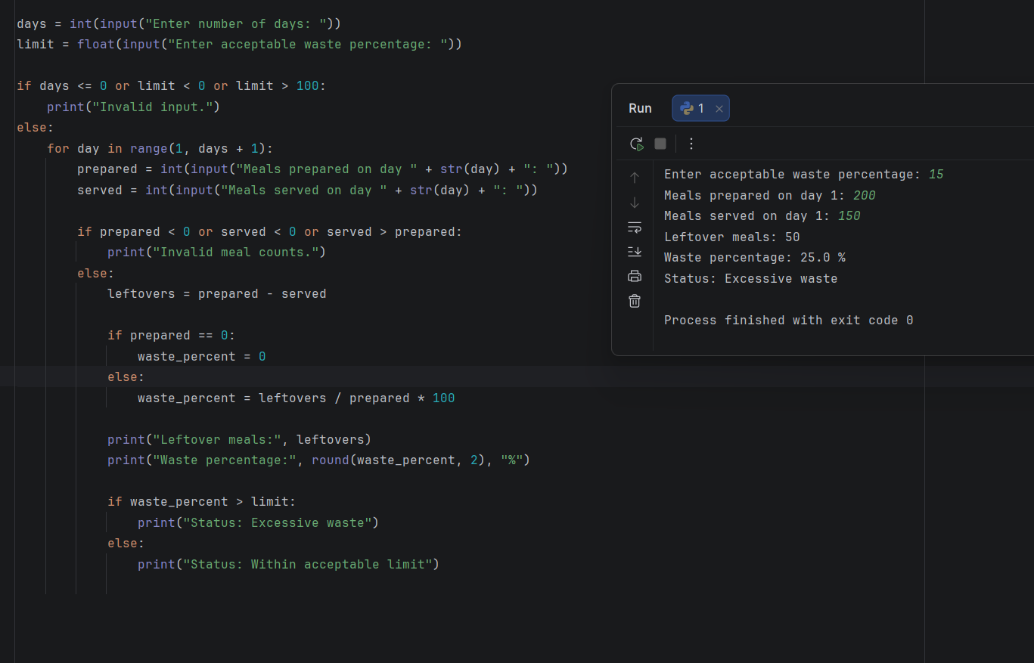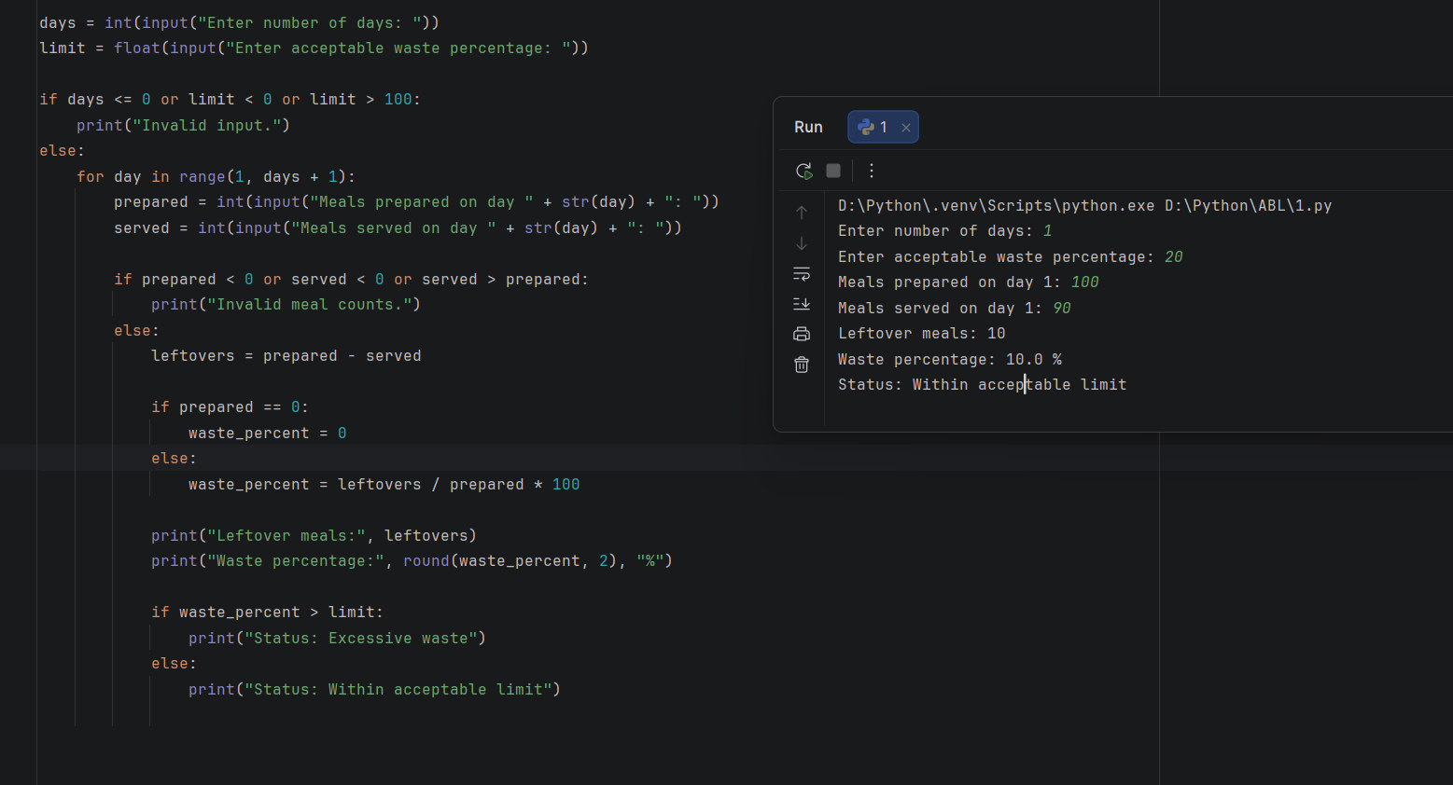

Conclusion
The program uses arithmetic and conditions to monitor leftover food and flag days with high waste

3.

Problem statement
Calculate an electricity bill based on the number of units consumed, using different rates for different usage levels.

Objectives
- Read electricity units.
- Calculate the bill using progressive rates.
- Display the total bill.

Assumptions
- First 100 units: ₹2 per unit.
- Next 100 units: ₹3 per unit.
- Units above 200: ₹5 per unit.
- No additional fixed charges.

Algorithm
- Start.
- Read units consumed.
- If units are negative, display invalid input.
- Otherwise, calculate the bill using the applicable slabs.
- Display the bill.
- Stop.

Flowchart
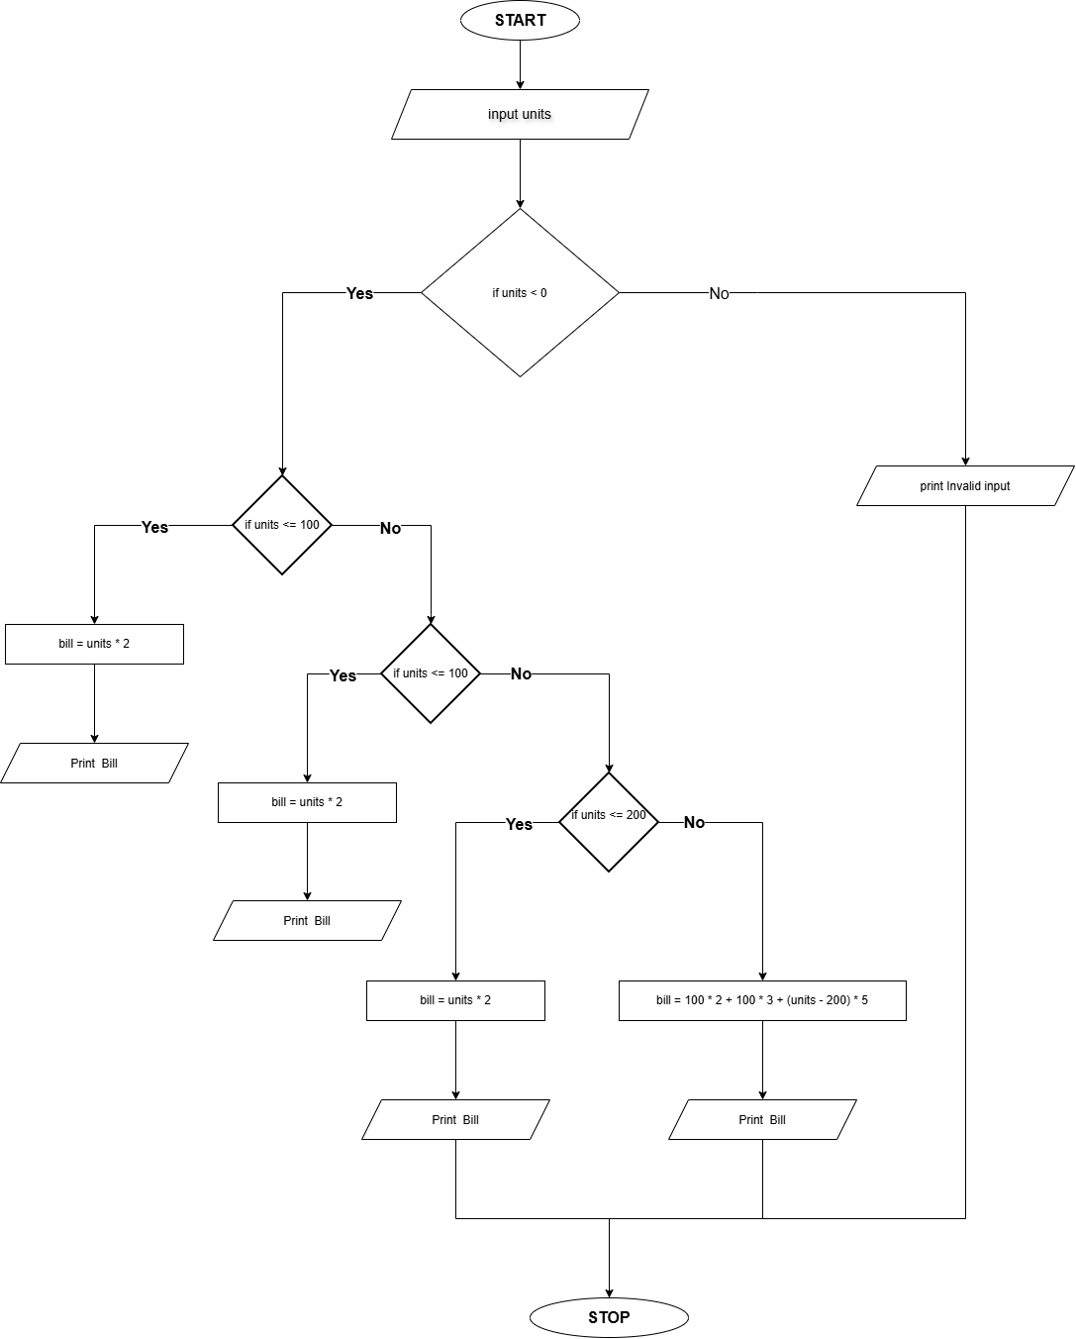

Pseudocode
Start
Input units
if units < 0
print "Invalid input"
else IF units <= 100
bill = units * 2
ELSE IF units <= 200
bill = 100 * 2 + (units - 100) * 3
ELSE
bill = 100 * 2 + 100 * 3 + (units - 200) * 5
PRINT bill
STOP

Source Code
units = int(input("Enter electricity units: "))
if units < 0:
print("Invalid input.")
elif units <= 100:
bill = units * 2
print("Electricity bill: Rs.", bill)
elif units <= 200:
bill = 100 * 2 + (units - 100) * 3
print("Electricity bill: Rs.", bill)
else:
bill = 100 * 2 + 100 * 3 + (units - 200) * 5
print("Electricity bill: Rs.", bill)

Test Cases
  - Enter electricity units: 80
Electricity bill: Rs. 160
  - Enter electricity units: 250
Electricity bill: Rs. 750

Output

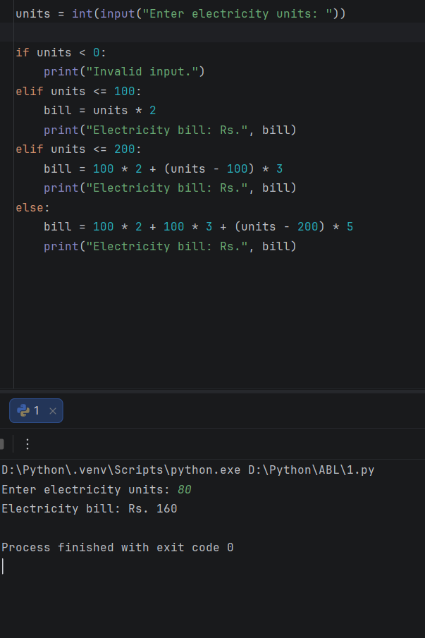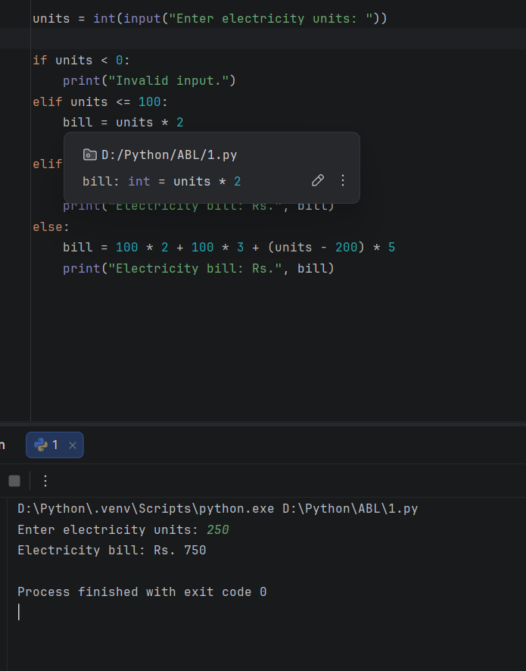

Conclusion
The program calculates electricity charges using progressive rates.

4.
Hospital Billing and Patient Classification: Process consultation, diagnostic, and treatment charges, apply conditional concessions, validate billing constraints, and classify patients according to a supplied payment policy.
Sol:

Problem statement
Calculate a patient's hospital bill based on the number of days admitted and the daily room charge. Classify the bill amount.

Objectives
- To calculate the hospital bill based on admission days.
- To classify the bill into Low, Medium, or High.
- To display the total bill and its category.

Assumptions
- Daily room charge is ₹1,000.
- Bills below ₹5,000 are classified as Low.
- Bills from ₹5,000 to ₹10,000 are Medium.
- Bills above ₹10,000 are High.

Algorithm
- Read the number of admission days.
- Validate the number of days.
- Calculate the total bill.
- Classify the bill amount.
- Display the bill and classification.

Flowchart

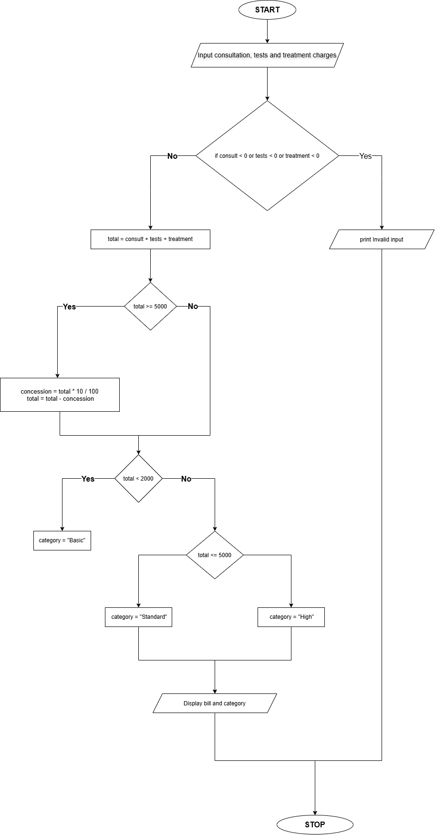

Pseudocode
START
INPUT consultation, diagnostic, treatment
IF any charge is negative:
DISPLAY "Invalid charges"
ELSE:
total = consultation + diagnostic + treatment
IF total >= 5000:
total = total - total * 10 / 100
IF total < 2000:
category = "Basic"
ELSE IF total <= 5000:
category = "Standard"
ELSE:
category = "High"
DISPLAY total
DISPLAY category
STOP

Source Code

consult = float(input("Consultation charge: "))
tests = float(input("Diagnostic charges: "))
treatment = float(input("Treatment charges: "))
if consult < 0 or tests < 0 or treatment < 0:
print("Invalid charges.")
else:
total = consult + tests + treatment
if total >= 5000:
concession = total * 10 / 100
total = total - concession
if total < 2000:
category = "Basic"
elif total <= 5000:
category = "Standard"
else:
category = "High"
print("Final bill: Rs.", round(total, 2))
print("Patient category:", category)

Test Cases
- Consultation charge: 500
Diagnostic charges: 300
Treatment charges: 700
Output:
Final bill: Rs. 1500.0
Patient category: Basic
- Consultation charge: 2000
Diagnostic charges: 1500
Treatment charges: 2500
Output:
Final bill: Rs. 5400.0
Patient category: High

Output
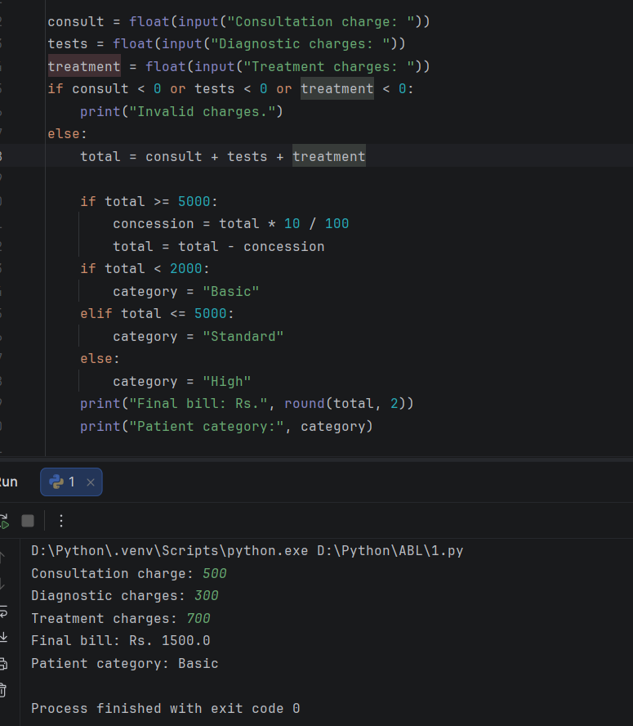
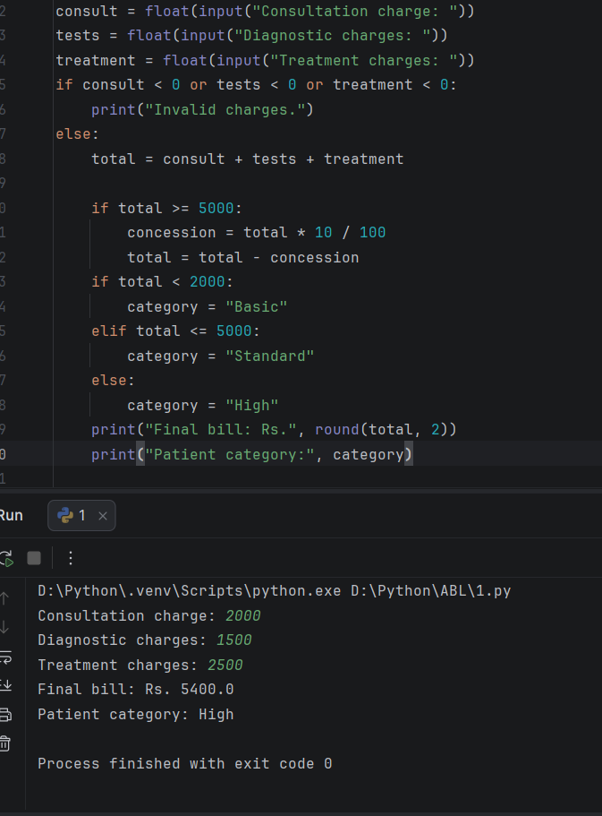

Conclusion
The program calculates hospital bills, applies a concession when eligible, validates charges, and classifies patients using conditional statements.

5.
ATM Transaction Sequence Simulation: Process a sequence of deposits and withdrawals, maintain a simulated balance, enforce withdrawal limits, reject invalid transactions, and produce a transaction summary.

Problem statement
Develop a Python program that processes a sequence of ATM deposits and withdrawals, updates the account balance, rejects invalid transactions, and displays a transaction summary.

Objectives
- Perform deposits and withdrawals.
- Maintain the current balance.
- Reject invalid or unaffordable transactions.
- Count successful and rejected transactions.

Assumptions
- The starting balance cannot be negative.
- The transaction type is D for deposit or W for withdrawal.
- Each transaction amount must be positive.
- Withdrawals cannot exceed the available balance.

Algorithm
- Start.
- Input the starting balance and number of transactions.
- Set successful and rejected transaction counts to zero.
- Repeat for each transaction.
- Input the transaction type and amount.
- If the transaction is valid, update the balance and successful count.
- Otherwise, increase the rejected count.
- Display the final balance and transaction counts.
- Stop.

Flowchart
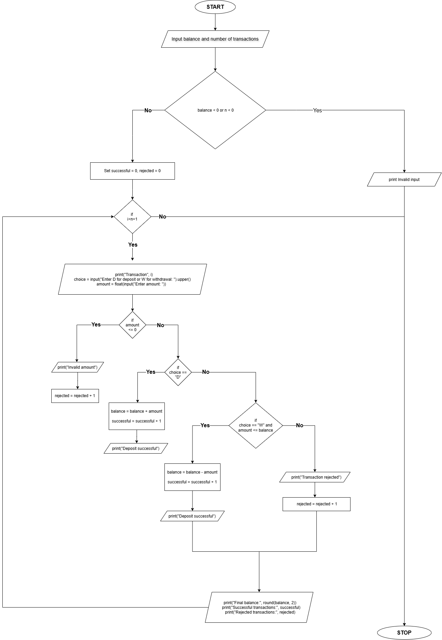

Pseudocode

START
INPUT balance, n
SET successful = 0
SET rejected = 0
REPEAT n times
INPUT type, amount
IF amount <= 0
rejected = rejected + 1
ELSE IF type = "D"
balance = balance + amount
successful = successful + 1
ELSE IF type = "W" AND amount <= balance
balance = balance - amount
successful = successful + 1
ELSE
rejected = rejected + 1
PRINT final balance
PRINT successful transactions
PRINT rejected transactions
END

Source Code

balance = float(input("Enter starting balance: "))
n = int(input("How many transactions? "))
if balance < 0 or n < 0:
print("Invalid input.")
else:
successful = 0
rejected = 0
for i in range(1, n + 1):
print("Transaction", i)
choice = input("Enter D for deposit or W for withdrawal: ").upper()
amount = float(input("Enter amount: "))
if amount <= 0:
print("Invalid amount")
rejected = rejected + 1
elif choice == "D":
balance = balance + amount
successful = successful + 1
print("Deposit successful")
elif choice == "W" and amount <= balance:
balance = balance - amount
successful = successful + 1
print("Withdrawal successful")
else:
print("Transaction rejected")
rejected = rejected + 1
print("Final balance:", round(balance, 2))
print("Successful transactions:", successful)
print("Rejected transactions:", rejected)

Test Cases
  - Enter starting balance: 1000
How many transactions? 2
Transaction 1
Enter D for deposit or W for withdrawal: D
Enter amount: 500
Transaction 2
Enter D for deposit or W for withdrawal: W
Enter amount: 200
Output:
Transaction 1
Deposit successful
Transaction 2
Withdrawal successful
Final balance: 1300.0
Successful transactions: 2
Rejected transactions: 0
  - Enter starting balance: 500
How many transactions? 2
Transaction 1
Enter D for deposit or W for withdrawal: W
Enter amount: 700
Transaction 2
Enter D for deposit or W for withdrawal: D
Enter amount: 200
Output
Transaction 1
Transaction rejected
Transaction 2
Deposit successful
Final balance: 700.0
Successful transactions: 1
Rejected transactions: 1

Output
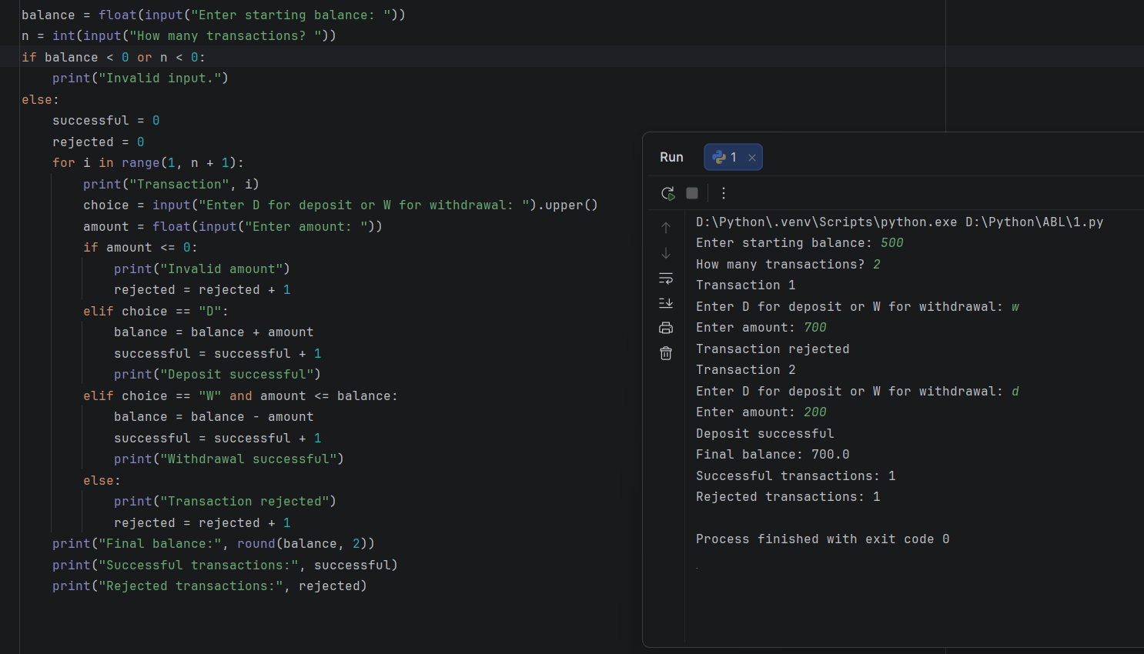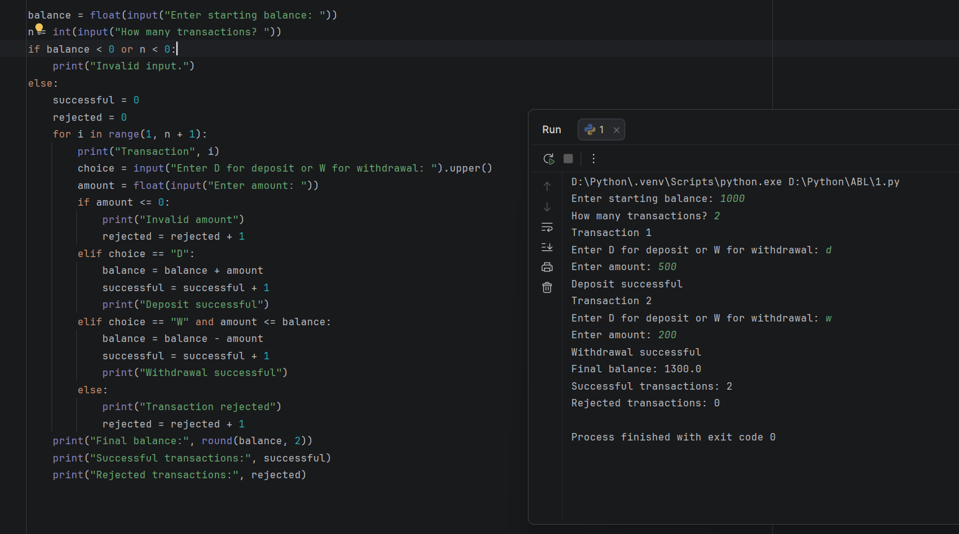

Conclusion
The program simulates ATM transactions using loops, conditions, and arithmetic operations. It also tracks successful and rejected transactions.

6.
The program simulates ATM transactions using loops, conditions, and arithmetic operations. It also tracks successful and rejected transactions.
Sol:

Problem statement
Calculate passenger fares using distance, travel class, age concessions, reservation fees and cancellation penalties.

Objectives
- Calculate distance-based fares.
- Apply class charges and age concessions.
- Calculate reservation and cancellation charges.

Assumptions
- Base fare is ₹2 per kilometre.
- Class multipliers are 1 for Sleeper and 2 for AC.
- Passengers aged 60 or above receive a 20% concession.
- Reservation fee is ₹50 per passenger.
- Cancellation penalty is 10% of the fare after concession.

Algorithm
- Input passenger details, distance and class.
- Calculate the base fare.
- Apply the class multiplier.
- Apply the age concession, if eligible.
- Add the reservation fee.
- Calculate the cancellation penalty.
- Display the fare details.

Flowchart
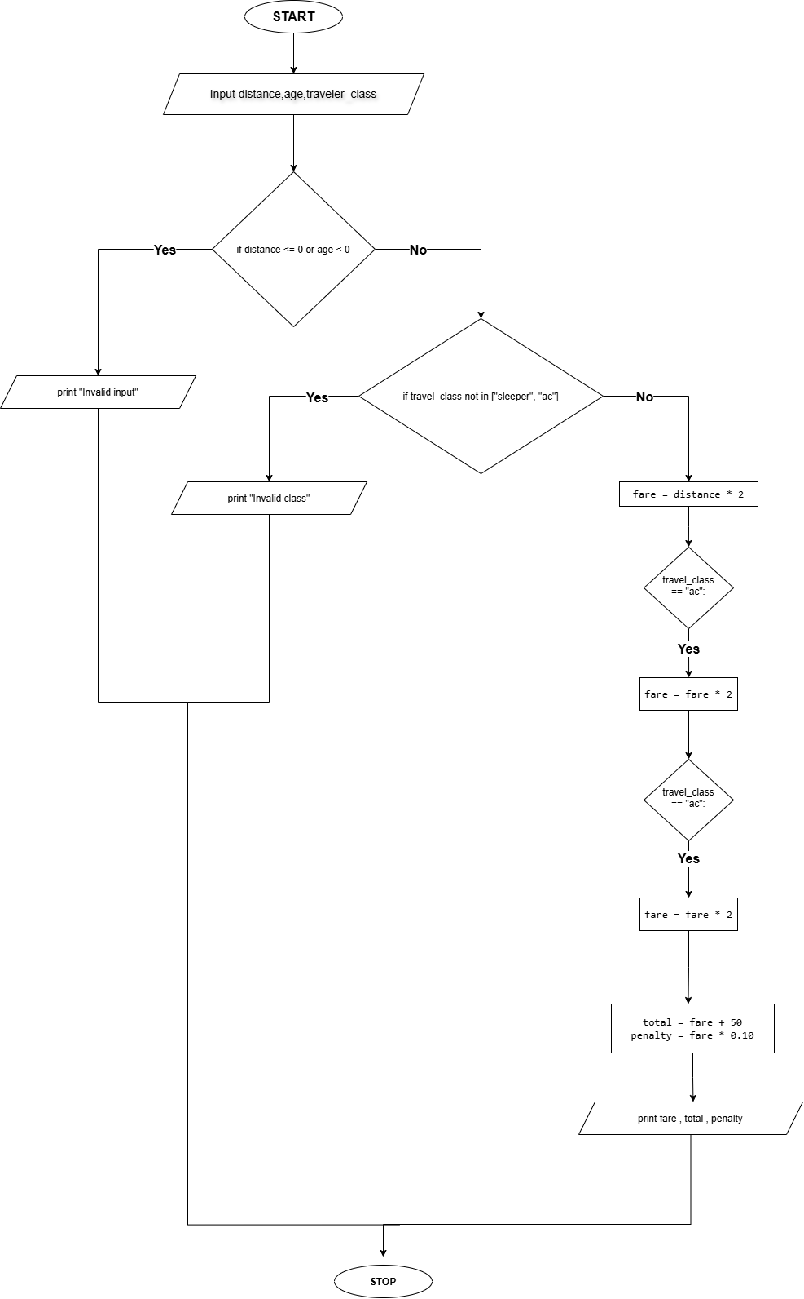

Pseudocode
START
INPUT distance, age, class
CALCULATE base fare
APPLY class multiplier
IF age >= 60
APPLY concession
END IF
ADD reservation fee
CALCULATE cancellation penalty
DISPLAY fare and penalty
STOP

Source Code
distance = float(input("Enter distance in km: "))
age = int(input("Enter passenger age: "))
travel_class = input("Enter Sleeper or AC: ").lower()
if distance <= 0 or age < 0:
print("Invalid input")
elif travel_class not in ["sleeper", "ac"]:
print("Invalid class")
else:
fare = distance * 2
if travel_class == "ac":
fare = fare * 2
if age >= 60:
fare = fare * 0.80
total = fare + 50
penalty = fare * 0.10
print("Fare after concession:", fare)
print("Total fare:", total)
print("Cancellation penalty:", penalty)

Test Cases
  - Enter distance in km: 200
Enter passenger age: 25
Enter Sleeper or AC: Sleeper
Output
Fare after concession: 400.0
Total fare: 450.0
Cancellation penalty: 40.0
  - Enter distance in km: 300
Enter passenger age: 65
Enter Sleeper or AC: AC
Output
Fare after concession: 960.0
Total fare: 1010.0
Cancellation penalty: 96.0

Output
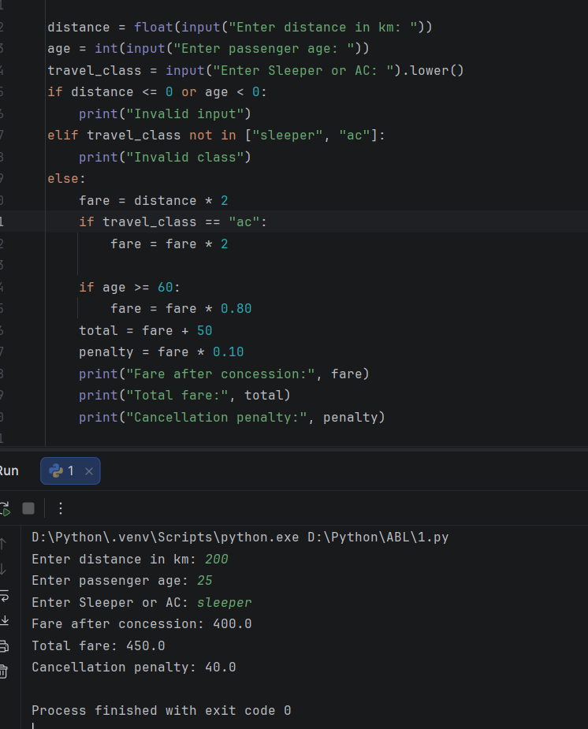

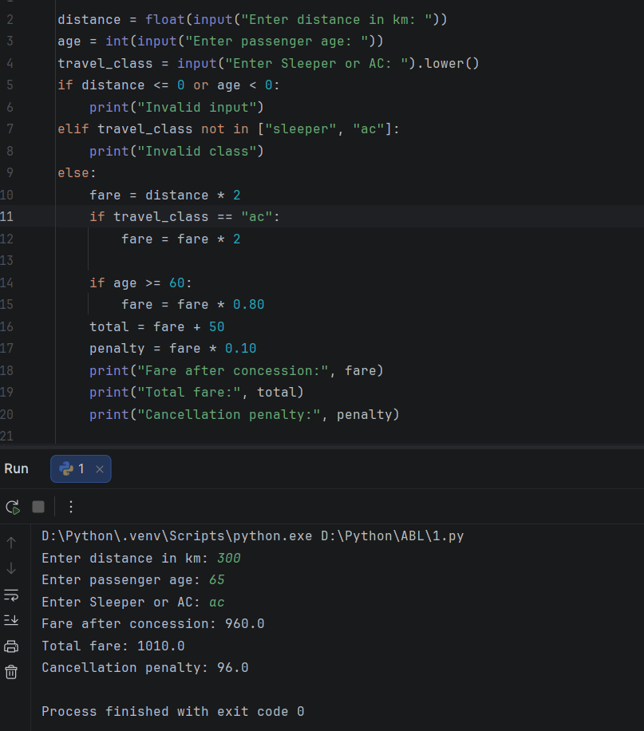

Conclusion
The program calculates railway fares and cancellation penalties according to the stated rules.

7.
Smart Parking Fee Management: Calculate charges from entry and exit times, vehicle categories, overnight parking, daily limits, and penalty conditions while validating time inputs.
Sol:

Problem statement
Calculate parking fees using entry and exit times, vehicle categories, overnight parking, daily limits and penalties.

Objectives
- Calculate parking duration.
- Apply different vehicle rates.
- Apply daily limits and overnight charges.

Assumptions
- Entry and exit are entered as hours from 0 to 23.
- Duration is calculated within one day; exit must be later than entry.
- Car rate is ₹30 per hour; bike rate is ₹15 per hour.
- Any partial hour is charged as a full hour.
- Maximum charge is ₹200 for a car and ₹100 for a bike.

Algorithm
- Input entry time, exit time and vehicle type.
- Validate the inputs.
- Calculate duration.
- Round duration up to the next whole hour.
- Calculate the fee.
- Apply the daily maximum.
- Display the fee.

Flowchart
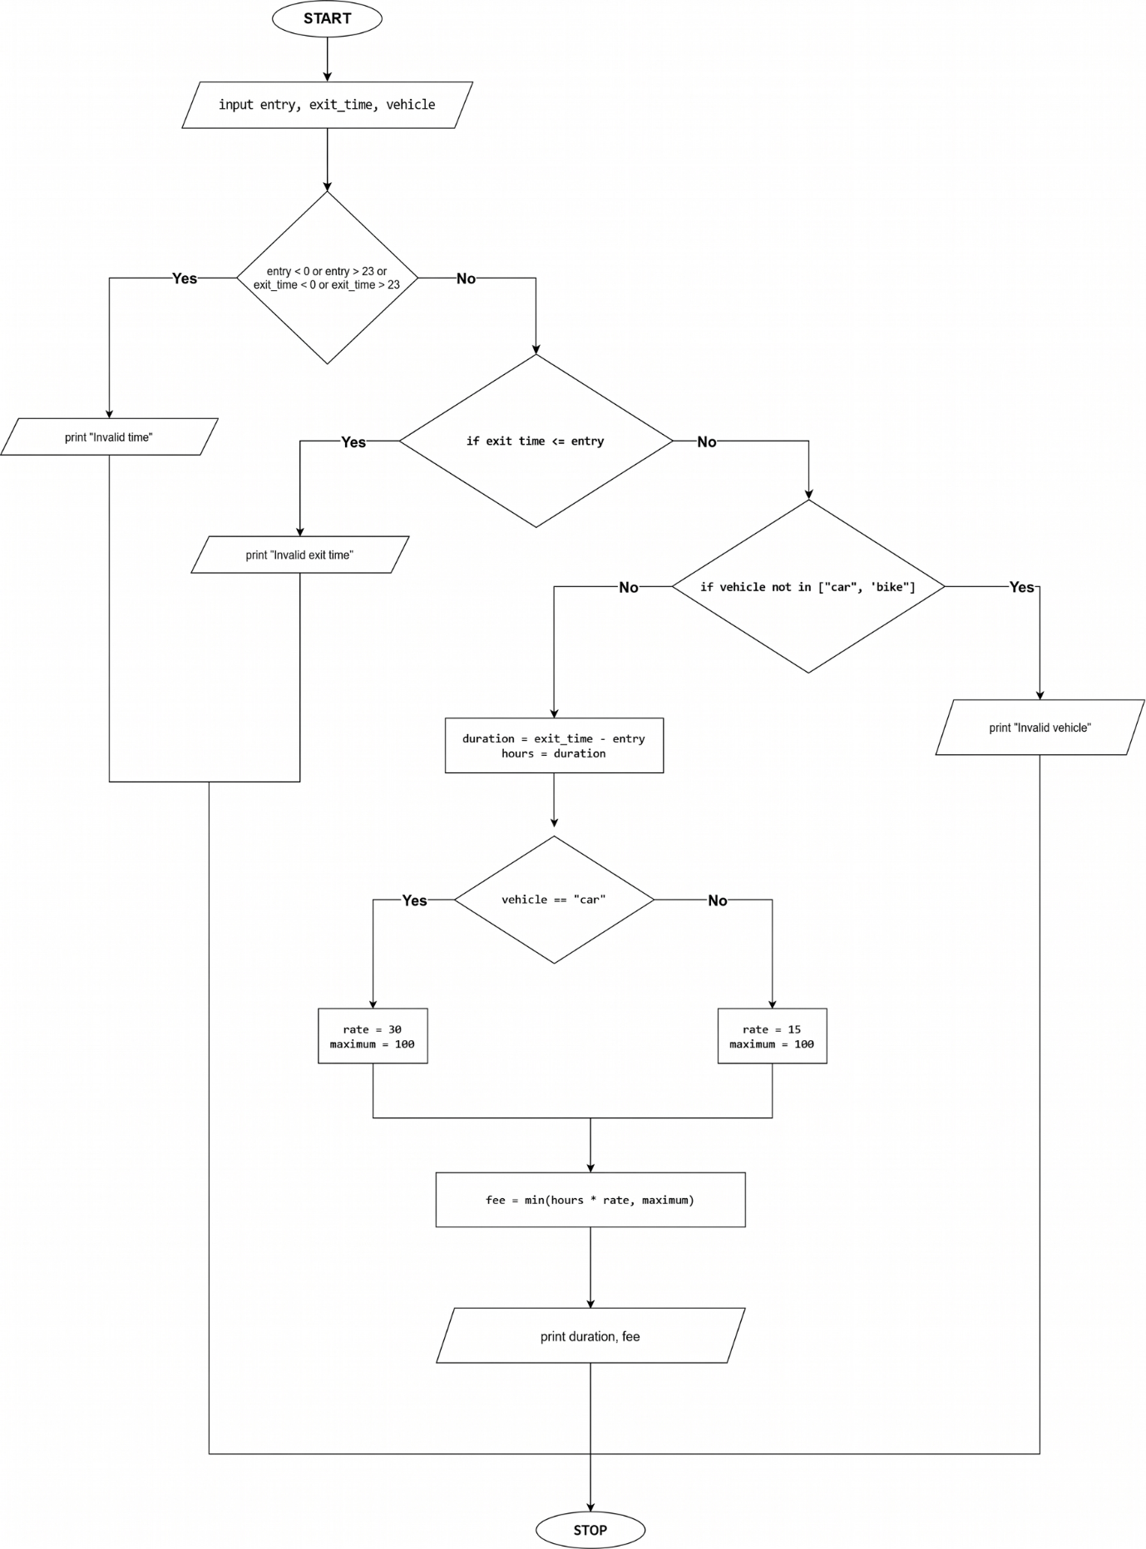

Pseudocode
START
INPUT entry, exit, vehicle
IF inputs are invalid
DISPLAY error
ELSE
duration = exit - entry
CALCULATE rounded hours
SELECT vehicle rate and maximum
fee = minimum of calculated fee and maximum
DISPLAY fee
END IF
STOP

Source Code
entry = int(input("Entry hour (0-23): "))
exit_time = int(input("Exit hour (0-23): "))
vehicle = input("Vehicle (car/bike): ").lower()
if entry < 0 or entry > 23 or exit_time < 0 or exit_time > 23:
print("Invalid time")
elif exit_time <= entry:
print("Invalid exit time")
elif vehicle not in ["car", "bike"]:
print("Invalid vehicle")
else:
duration = exit_time - entry
hours = duration
if vehicle == "car":
rate = 30
maximum = 200
else:
rate = 15
maximum = 100
fee = min(hours * rate, maximum)
print("Parking duration:", duration, "hours")
print("Parking fee: Rs.", fee)

Test Cases
- Entry hour (0-23): 9
Exit hour (0-23): 13
Vehicle (car/bike): car
Output
Parking duration: 4 hours
Parking fee: Rs. 120
- Entry hour (0-23): 8
Exit hour (0-23): 18
Vehicle (car/bike): bike
Output
Parking duration: 10 hours
Parking fee: Rs. 100

Output
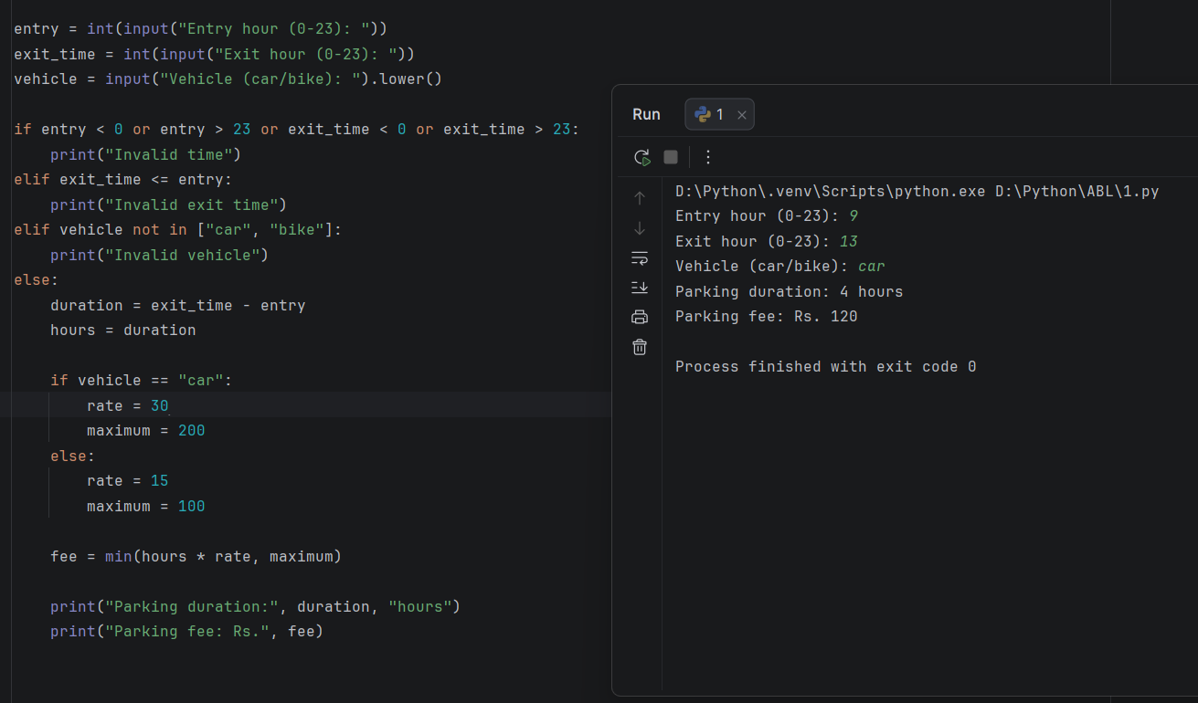
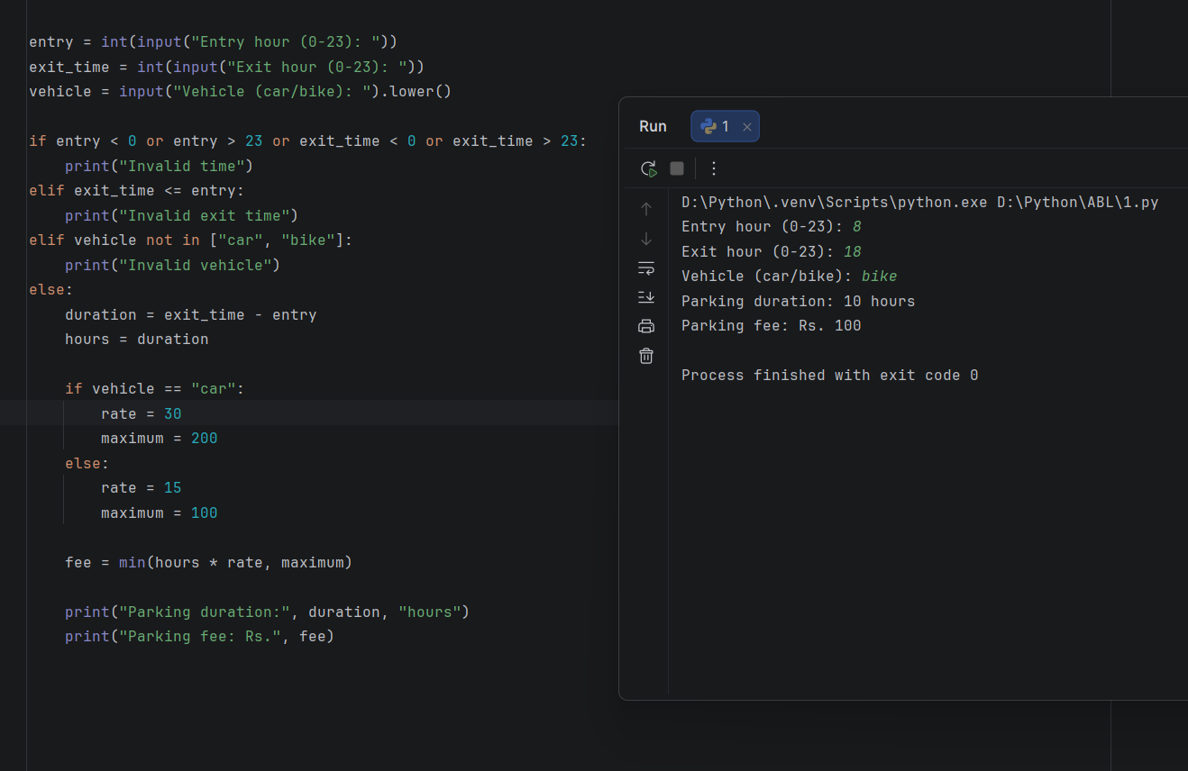

Conclusion
The program calculates parking fees using vehicle rates and maximum charges.

8.
Student Performance Trend Analysis: Compare assessment scores across multiple examinations, calculate improvements and declines, identify consistently weak subjects, and classify students according to defined criteria.

Problem Statement
Compare assessment scores across examinations, calculate improvements and declines, identify weak subjects, and classify students.

Objectives
- Calculate score changes.
- Identify weak subjects.
- Classify performance.

Assumptions
- Three subjects and two examinations are considered.
- Scores range from 0 to 100.
- A subject is weak if the latest score is below 40.
- Average score of 75 or more is classified as Good; otherwise, Needs Improvement.

Algorithm
- Input the student's name.
- Input earlier and latest scores for three subjects.
- Calculate the average latest score.
- Calculate each subject's score change.
- Identify weak subjects.
- Classify overall performance.
- Display the report.

Flowchart

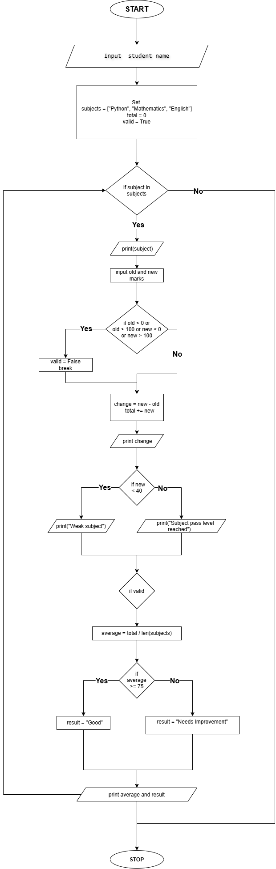

Pseudocode
START
INPUT student name
FOR each subject
INPUT earlier and latest marks
CALCULATE change
CHECK weak subject
END FOR
CALCULATE average
IF average >= 75
classification = Good
ELSE
classification = Needs Improvement
END IF
DISPLAY report
STOP

Source Code
name = input("Student name: ")
subjects = ["Python", "Mathematics", "English"]
total = 0
valid = True
for subject in subjects:
print(subject)
old = int(input("Earlier marks: "))
new = int(input("Latest marks: "))
if old < 0 or old > 100 or new < 0 or new > 100:
valid = False
print("Invalid marks")
break
change = new - old
total += new
print("Change:", change)
if new < 40:
print("Weak subject")
else:
print("Subject pass level reached")
if valid==True:
average = total / len(subjects)
if average >= 75:
result = "Good"
else:
result = "Needs Improvement"
print("Average:", average)
print("Performance:", result)

Test Cases
  - Student name:Mikasa
Python
Earlier marks: 60
Latest marks: 80
Mathematics
Earlier marks: 70
Latest marks: 85
English
Earlier marks: 65
Latest marks: 90
Output
Python
Change: 20
Subject pass level reached
Mathematics
Change: 15
Subject pass level reached
English
Change: 25
Subject pass level reached
Average: 85.0
Performance: Good

  - Student name:Shadow
Python
Earlier marks: 50
Latest marks: 35
Mathematics
Earlier marks: 60
Latest marks: 55
English
Earlier marks: 70
Latest marks: 60
Output
Python
Change: -15
Weak subject
Mathematics
Change: -5
Subject pass level reached
English
Change: -10
Subject pass level reached
Average: 50.0
Performance: Needs Improvement

Output
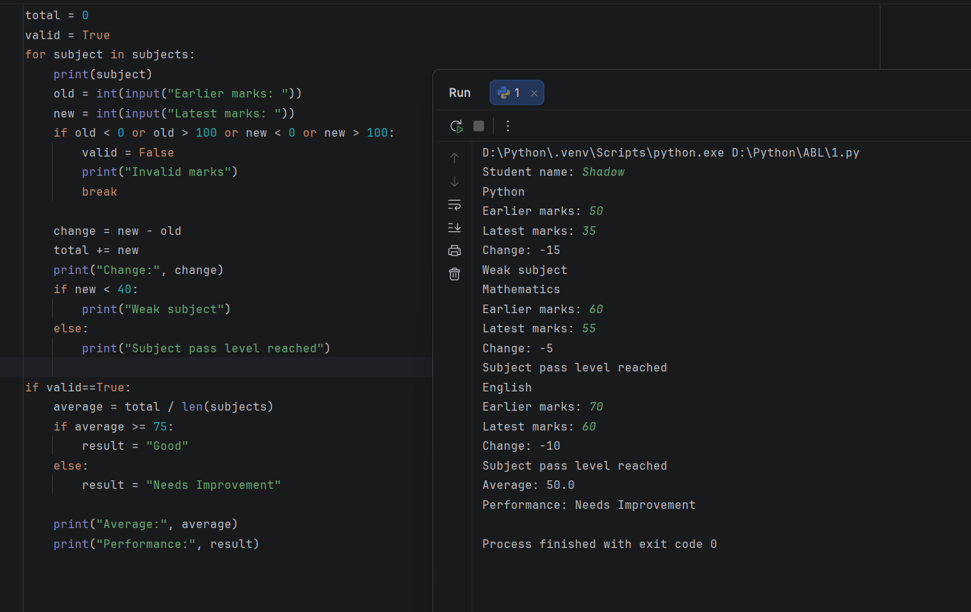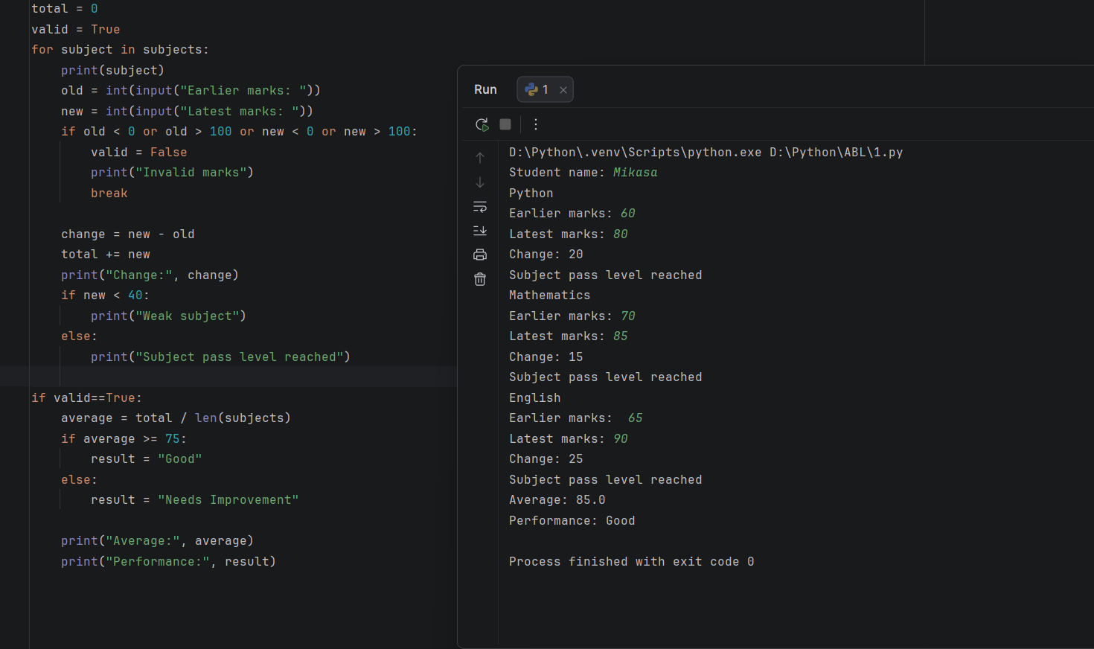

Conclusion
The program analyses student performance across examinations and identifies improvements, declines and weak subjects.

9.
Courier Charge Optimization: Calculate delivery charges based on parcel weight, dimensions, distance zones, urgency, and declared restrictions; compare service options and select an eligible one.

Problem Statement
Calculate courier charges based on parcel weight, dimensions, distance zones, urgency, and restrictions. Compare service options and select an eligible one.

Objectives
- Calculate charges for different courier services.
- Apply urgency charges.
- Reject parcels exceeding service limits.
- Select the cheapest eligible service.

Assumptions
- Standard service costs ₹40 plus ₹10 per kg.
- Express service costs ₹70 plus ₹15 per kg.
- Parcels over 5 kg are not accepted.
- Express delivery adds ₹30 for urgent service.
- The parcel must have positive weight and valid dimensions.

Algorithm
- Input parcel weight, dimensions, distance zone and urgency.
- Validate the inputs.
- Calculate the standard and express charges.
- Check each service's eligibility.
- Compare eligible charges.
- Display the cheapest eligible service.

Flowchart
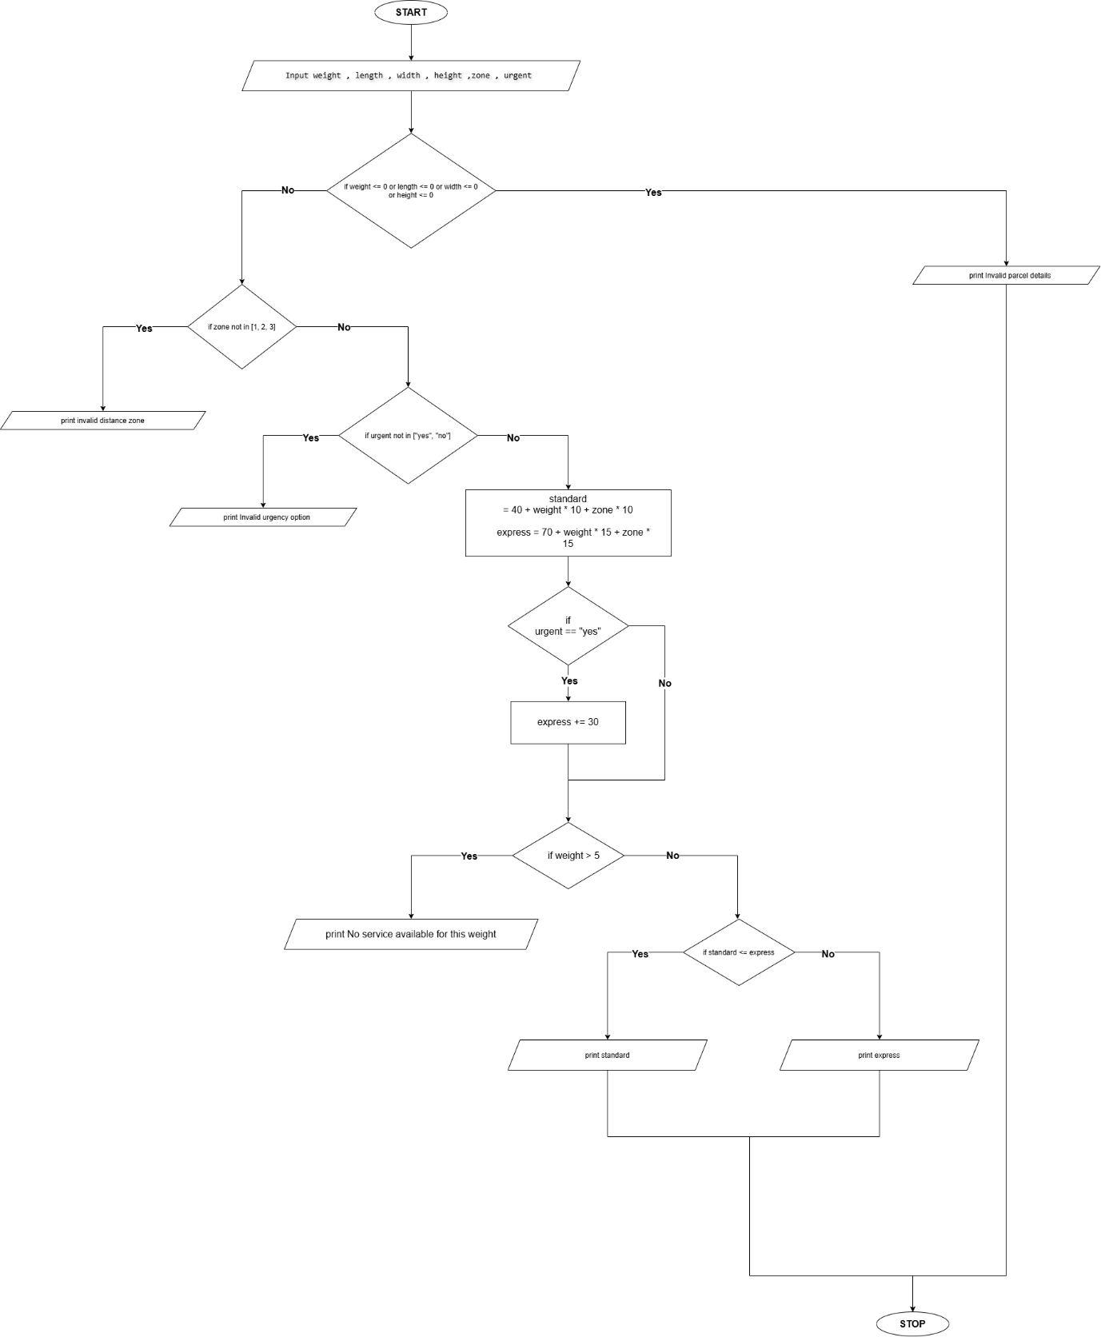

Pseudocode
START
INPUT weight, dimensions, zone, urgency
VALIDATE inputs
CALCULATE standard and express charges
CHECK service eligibility
SELECT cheapest eligible service
DISPLAY result
STOP

Source Code
weight = float(input("Parcel weight in kg: "))
length = float(input("Length in cm: "))
width = float(input("Width in cm: "))
height = float(input("Height in cm: "))
zone = int(input("Distance zone (1-3): "))
urgent = input("Urgent delivery? (yes/no): ").lower()
if weight <= 0 or length <= 0 or width <= 0 or height <= 0:
print("Invalid parcel details")
elif zone not in [1, 2, 3]:
print("Invalid distance zone")
elif urgent not in ["yes", "no"]:
print("Invalid urgency option")
else:
standard = 40 + weight * 10 + zone * 10
express = 70 + weight * 15 + zone * 15
if urgent == "yes":
express += 30
if weight > 5:
print("No service available for this weight")
elif standard <= express:
print("Selected service: Standard")
print("Charge: Rs.", standard)
else:
print("Selected service: Express")
print("Charge: Rs.", express)

Test Cases
  - Parcel weight in kg: 2
Length in cm: 20
Width in cm: 15
Height in cm: 10
Distance zone (1-3): 1
Urgent delivery? (yes/no): no
Output
Selected service: Standard
Charge: Rs. 70.0

  - Parcel weight in kg: 3
Length in cm: 30
Width in cm: 20
Height in cm: 15
Distance zone (1-3): 2
Urgent delivery? (yes/no): yes
Output
Selected service: Standard
Charge: Rs. 90.0

Output
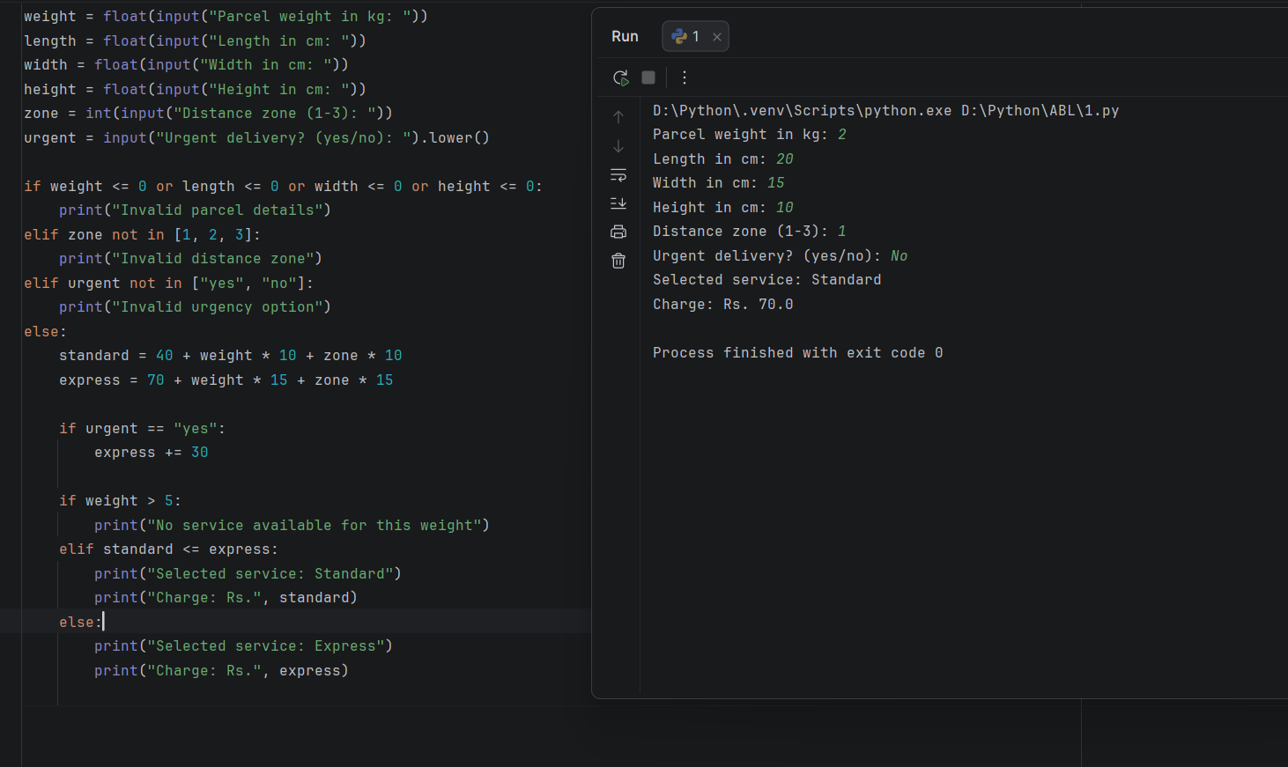
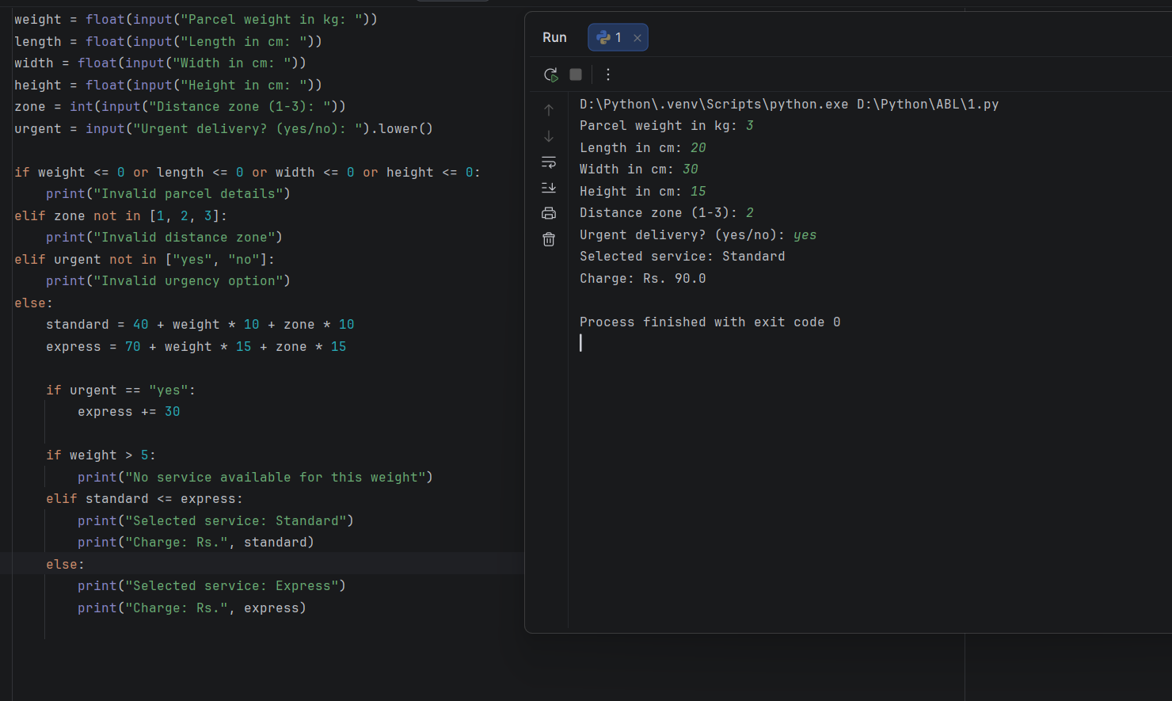

Conclusion
The program compares courier services, calculates charges and selects the cheapest eligible option.

10.
Campus Transport Allocation: Determine the number of buses needed for several routes, account for bus capacities and passenger demand, and identify unserved passengers.

Problem statement
Develop a Python program to calculate the number of buses required for campus routes based on passenger demand and bus capacity. Identify the number of passengers who cannot be served if the available buses are insufficient.

Objectives
- Input passenger demand and bus capacity.
- Calculate the number of buses required.
- Allocate the available buses.
- Find unserved passengers.

Assumptions
- Each bus has the same capacity.
- Each passenger requires one seat.
- The available bus count is shared across routes in input order.
- Passenger demand and bus capacity must be valid non-negative integers, with bus capacity greater than zero.

Algorithm
- Start.
- Input the number of routes.
- Input the capacity of each bus and the number of available buses.
- For each route, input passenger demand.
- Calculate required buses using ceiling division.
- Allocate available buses.
- Calculate passengers served and unserved.
- Display the result for each route.
- Stop.

Flowchart

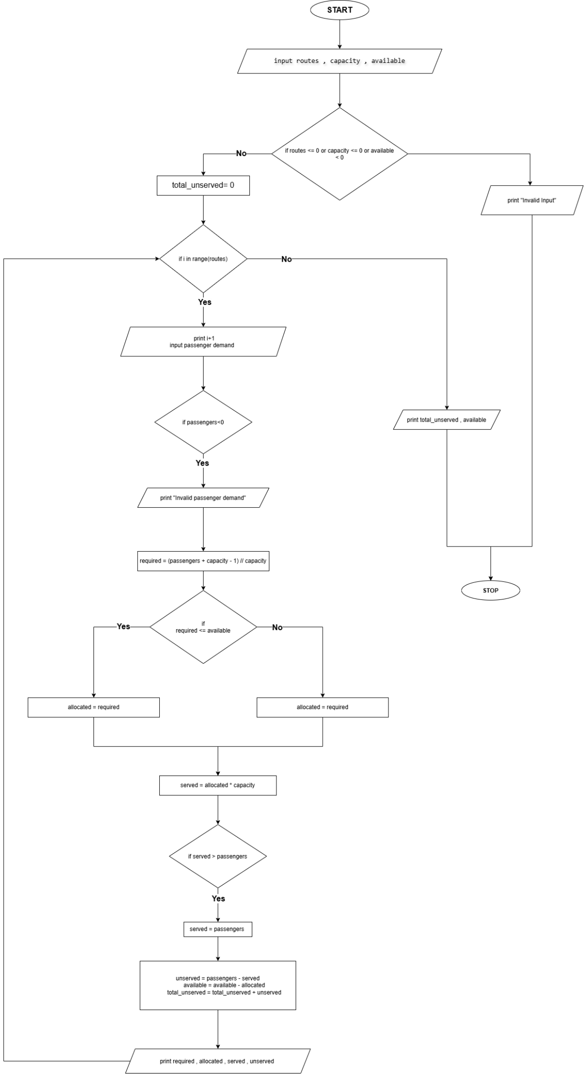

Pseudocode
START
INPUT number of routes
INPUT bus capacity
INPUT available buses

FOR each route
INPUT passenger demand
CALCULATE buses required

ALLOCATE the smaller of:
buses required
remaining buses

CALCULATE passengers served
CALCULATE unserved passengers
UPDATE remaining buses
DISPLAY route summary
END FOR

STOP

Source Code
routes = int(input("Enter number of routes: "))
capacity = int(input("Enter capacity of each bus: "))
available = int(input("Enter available buses: "))
if routes <= 0 or capacity <= 0 or available < 0:
print("Invalid input")
else:
total_unserved = 0
for i in range(routes):
print("\nRoute", i + 1)
passengers = int(input("Enter passenger demand: "))
if passengers < 0:
print("Invalid passenger demand")
continue
required = (passengers + capacity - 1) // capacity
if required <= available:
allocated = required
else:
allocated = available
served = allocated * capacity
if served > passengers:
served = passengers
unserved = passengers - served
available = available - allocated
total_unserved = total_unserved + unserved
print("Buses required:", required)
print("Buses allocated:", allocated)
print("Passengers served:", served)
print("Unserved passengers:", unserved)
print("\nTotal unserved passengers:", total_unserved)
print("Buses remaining:", available)

Test Cases
  - Enter number of routes: 2
Enter capacity of each bus: 40
Enter available buses: 5

Route 1
Enter passenger demand: 75

Route 2
Enter passenger demand: 60
Output
Route 1
Buses required: 2
Buses allocated: 2
Passengers served: 75
Unserved passengers: 0

Route 2
Buses required: 2
Buses allocated: 2
Passengers served: 60
Unserved passengers: 0

Total unserved passengers: 0
Buses remaining: 1

  - Enter number of routes: 2
Enter capacity of each bus: 30
Enter available buses: 2

Route 1
Enter passenger demand: 50

Route 2
Enter passenger demand: 40
Output
Route 1
Buses required: 2
Buses allocated: 2
Passengers served: 50
Unserved passengers: 0

Route 2
Buses required: 2
Buses allocated: 0
Passengers served: 0
Unserved passengers: 40

Total unserved passengers: 40
Buses remaining: 0

Output
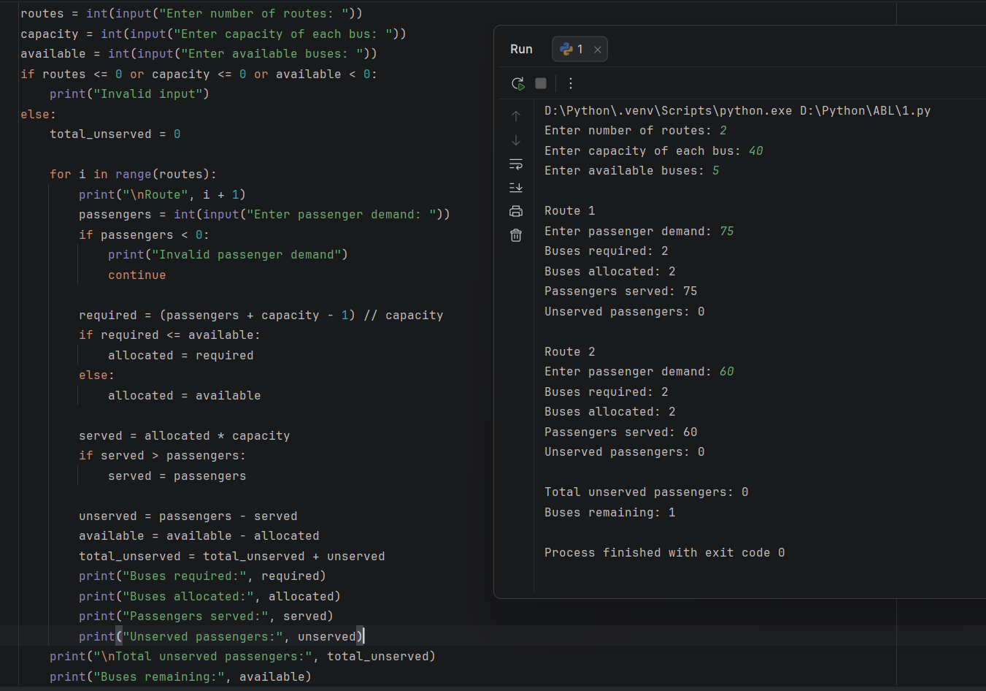
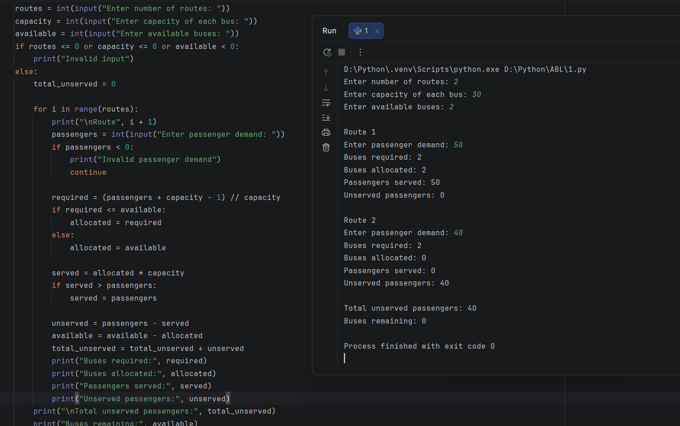

Conclusion
The program calculates bus requirements, allocates available buses in route order, and identifies passengers who cannot be served.

